
Quality Public Education Forum
Public Education



QPEC Education Forum 2021: Education for the public good

Sat 29 May, Part 1

10:00-11:30 Critical analysis of issues in education
Prof Peter O’Connor
Stephanie Mills
Simon Mitchell

1:00 – 2:30 Union panel
Liam Rutherford NZEI Te Riu Roa
Chris Abercrombie PPTA Te Wehengarua
Tina Smith TEU Te Hautū Kahurangi

Join Zoom Meeting https://us02web.zoom.us/j/8229464633?pwd=TWVteWNObzZWUmVrV1JQU0NTV01wUT09
Meeting ID: 822 946 4633 Passcode: QPEC2021

One tap mobile Dial by your location
+6448860026,,8229464633# New Zealand +64 4 886 0026
+6498846780,,8229464633# New Zealand +64 9 884 6780
64 3 659 0603 New Zealand
Meeting ID: 822 946 4633

Chairperson for Critical Issues panel of speakers
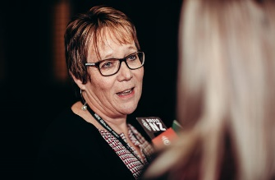
Tracey Martin held a number of Cabinet positions including that of an Associate Minister of Education in the 2017 - 2020 Government. She was on the political panel of speakers in QPEC’s 2019 and 2020 Forums. Since leaving parliament she has been named as the head of a governance group appointed to oversee a new public media plan for New Zealand.

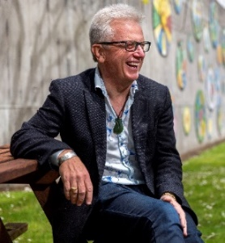
Professor Peter O’Connor University of Auckland Faculty of Education and Social Work
Peter O’Connor is Professor of Education and Director of the Centre for Arts and Social Transformation at the University of Auckland. He is the National Education spokesperson for Child Poverty Action Group, former National Education Manager for the Race Relations Office and was President of the Foundation for Peace Studies for ten years. His research centres on the possibilities of education and the arts to make a more socially just and inclusive Aotearoa. (Click on link)
Prof. Peter O'Connor, University of Auckland

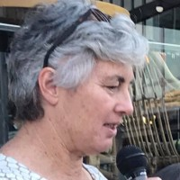
Stephanie Mills – Director of Campaigns at NZEI Te Riu Roa
As Director of Campaigns at NZEI Te Riu Roa, Stephanie headed the ECE Voice Campaign and Strategy overview creating NZEI Te Riu Roa as the tūrangawaewae for ECE.

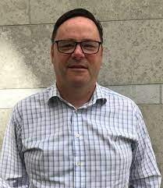
Simon Mitchell – Family & Employment Lawyer and BOT Parent chair & representative
Simon is a practising family & employment lawyer and is an activist in a range of social issues. His interest in education issues is informed by being a Board of Trustee parent representative and chair in both the primary and secondary sectors.

Chairperson for Panel of Unionists

Associate Professor Georgina Stewart
School of Education, AUT University Te Wānanga Aronui o Tāmaki Makau Rau. Formerly a secondary school teacher of Science, Mathematics and Māori in both English-medium and Māori-medium schools. I have published widely since 2005 on Māori science education and Māori philosophy of education. I recently completed a Marsden research project investigating academic writing in Māori.

Tina Smith - TEU Te Hautū Kahurangi
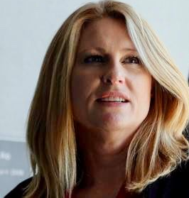
Tina was elected as the National President of TEU in 2020. She was previously a senior lecturer of nursing at Te Pae Mātauranga Ki te Ao Universal College of Learning (UCOL) in Palmerston North and has spent over 30 years working in the ITP sector. Tina has a strong commitment to te Tiriti O Waitangi and TEU’s te koeke tiriti framework. She is passionate about fairness, equity and quality public education that is available to all.

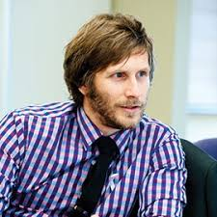
Liam Rutherford – NZEI Te Riu Roa
Liam is the current President of NZEI. He has a keen interest in politics that started at university, stemming from a strong belief in the power of public education to transform lives, and believes that it is the role of the Government to provide it. Liam sees New Zealand facing huge levels of inequality and believes that education is the way to close that gap.


Chris Abercrombie – PPTA Te Wehengarua
James Hargest College (Invercargill ) history teacher Chris Abercrombie said upon being recently elected to the PPTA Junior Vice President position that having had the experience of working in different positions in different schools and areas of New Zealand meant that he could be the voice that will speak for the wide range of teachers that we have in Aotearoa New Zealand.

