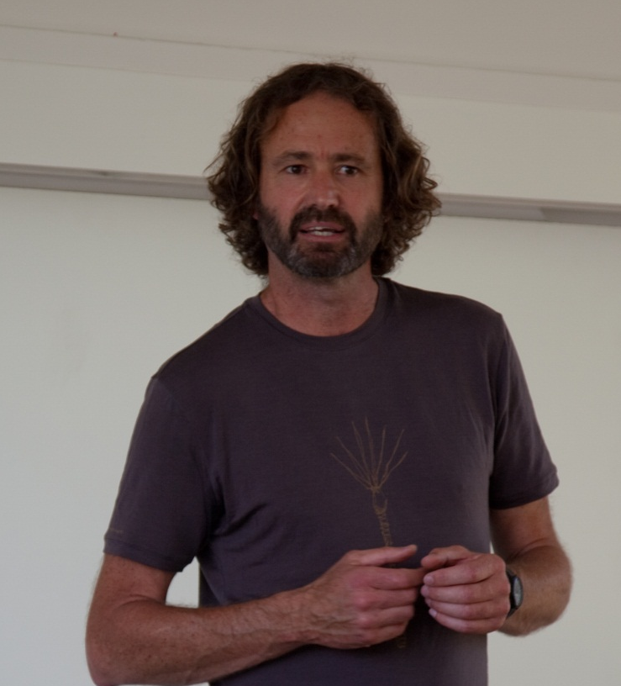 | Pax Christi Aotearoa NZ  invites you to  The 2nd Annual David Wakim Memorial Lecture  Title: Polluted inheritance: New Zealand’s freshwater crisis.  Speaker: Mike Joy BSc, MSc (1st class hons), PhD in Ecology, Senior Lecturer in Ecology and Environmental Science at the Ecology Group-Institute of Agriculture and Environment Massey University Palmerston North.  Mike is an outspoken advocate for environmental protection in New Zealand and has received numerous awards. Mike will describe the true state of freshwaters in New Zealand, a reality that is mostly covered up and denied. He will look at the drivers of the decline and the response from government - both central and local. He will discuss solutions and options for the future management of freshwater. The talk is based on his recently published book: Polluted Inheritance. New Zealand’s Freshwater Crisis.
The memorial lecture commemorates the life and work of David Wakim, first national president of Pax Christi Aotearoa-New Zealand who died on 2nd October 2005. | Venue: St Columba Centre, Vermont Street, Ponsonby  Date: Friday 30th September 2016  Time: 7.00 pm

